EWMA correlation: EURUSD and NZDUSD
Method 06 / daily log returns / lambda = 0.94 / Alpari D1 full available history

Study setup
Logical pair: EURUSD , NZDUSD
Broker symbols: EURUSD_i , NZDUSD_i
Snapshot: 2026-11-03_majors_alpari_D1
Timeframe: D1
Matched return window: 1999-01-05 to 2026-11-02 (UTC bar dates)
Matched return count n: 7186
Dropped unfinished last bar dated 2026-11-03 UTC after a tick-volume check against the prior complete day.
Lambda: 0.94 (today weight 0.06)
Burn-in ignored in path summaries and chart: first 60 updates
Mean adjustment: each leg demeaned by its mean on the matched rows
Seeds: c_0 = v_x,0 = v_y,0 = 0
Complete matched rows (Excel): EURUSD-NZDUSD_EWMA_D1.xlsx
Complete matched rows (HTML table): EURUSD-NZDUSD_EWMA_D1_data.html

Method carried forward
EWMA correlation updates covariance and variances of mean-adjusted daily log returns of close, ln(close_t / close_t-1), with lambda = 0.94 (6% weight on today's product or square, 94% on yesterday's EWMA state). Quotes are not inverted. Each leg is demeaned by its mean on the matched rows; that mean uses the full sample, so the rho path is a full-sample description, not a live filter. Seeds start at zero. Path summaries and the chart ignore the first 60 updates so the zero seed has faded. The headline is rho on the last day. rho is symmetric under swap of the two symbols. A high |rho| does not prove cause, lead-lag, or a trading signal. Today's return sits inside today's rho, so the estimate can only inform a later decision. Same-sample Pearson r is a side check only.

Results
Latest EWMA rho: 0.452453
Post-burn-in path (n=7126): mean=0.539542, median=0.573839, min=-0.280246, max=0.903521, std=0.201944
Share of post-burn-in days with |rho| >= 0.4: 76.78%; |rho| >= 0.7: 24.88%
Same-sample Pearson r: 0.549808
Latest rho minus r: -0.097355

Conclusion
Over 7186 matched daily log-return rows for EURUSD and NZDUSD (broker quote directions unchanged), latest EWMA rho with lambda=0.94 is 0.4525 (positive, moderate recent linear link in this sample). After a 60-day burn-in, path mean is 0.5395, std is 0.2019, and the range is [-0.2802, 0.9035]. Same-sample Pearson r is 0.5498 (latest rho minus r = -0.0974). This does not establish cause, lead-lag, or a lasting trading rule.

Charts
Daily closes

Daily log returns
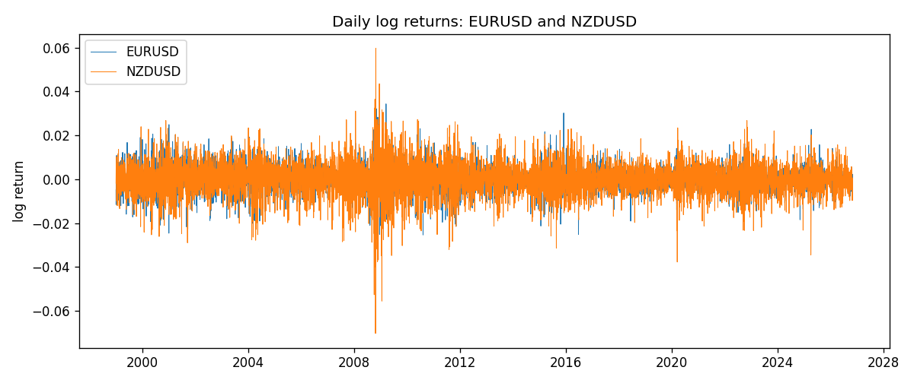
EWMA rho path with Pearson r reference
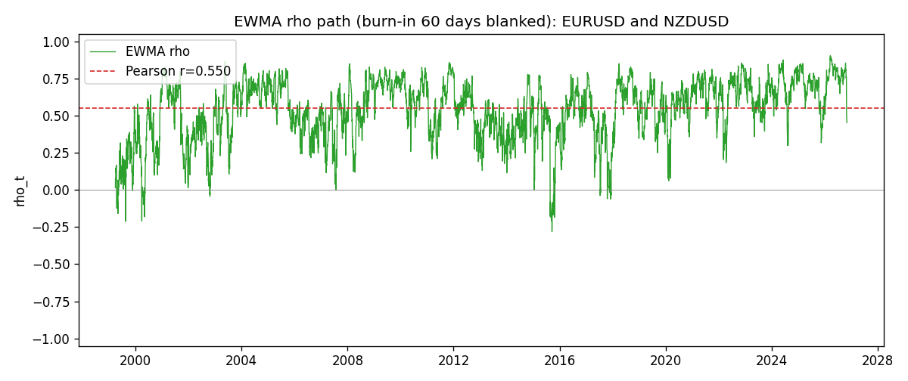

Data report
Every matched row that entered the EWMA recursion is stored in the sibling Excel workbook named EURUSD-NZDUSD_EWMA_D1.xlsx. That file is the complete data archive for redrawing charts. Embedding all rows as a Word table is impractical at this length; the Word file holds the column list, column summaries, and the first and last 15 matched rows.
Columns: time, EURUSD_open, NZDUSD_open, EURUSD_high, NZDUSD_high, EURUSD_low, NZDUSD_low, EURUSD_close, NZDUSD_close, EURUSD_tick_volume, NZDUSD_tick_volume, EURUSD_spread, NZDUSD_spread, EURUSD_real_volume, NZDUSD_real_volume, EURUSD_log_return, NZDUSD_log_return, EURUSD_x_demeaned, NZDUSD_y_demeaned, c_t, v_x, v_y, rho_t
Column summaries (matched calculation rows)
column | count | mean | std | min | 25% | 50% | 75% | max
EURUSD_open | 7186 | 1.181357 | 0.15085833 | 0.8272 | 1.086165 | 1.16609 | 1.2939475 | 1.5995
NZDUSD_open | 7186 | 0.65641776 | 0.10819833 | 0.3913 | 0.59134 | 0.6684 | 0.7249075 | 0.88218
EURUSD_high | 7186 | 1.1864878 | 0.15145386 | 0.8326 | 1.09024 | 1.17121 | 1.2993075 | 1.6038
NZDUSD_high | 7186 | 0.66033433 | 0.10869188 | 0.3961 | 0.59475 | 0.67202 | 0.72936 | 0.88421
EURUSD_low | 7186 | 1.1763494 | 0.15017707 | 0.8227 | 1.082045 | 1.162475 | 1.2884175 | 1.5865
NZDUSD_low | 7186 | 0.65273031 | 0.10779283 | 0.3897 | 0.5880725 | 0.664185 | 0.720965 | 0.87988
EURUSD_close | 7186 | 1.1813978 | 0.15082738 | 0.8267 | 1.0860425 | 1.16602 | 1.2939725 | 1.5997
NZDUSD_close | 7186 | 0.65649194 | 0.10819527 | 0.3907 | 0.59159 | 0.66842 | 0.725015 | 0.8822
EURUSD_tick_volume | 7186 | 103205.25 | 173535.32 | 218 | 9413.25 | 52774.5 | 99579.75 | 1471626
NZDUSD_tick_volume | 7186 | 68709.014 | 123134.25 | 16 | 5585.5 | 33893.5 | 58510.5 | 1127682
EURUSD_spread | 7186 | 19.350682 | 16.562781 | 0 | 8 | 12 | 27.5 | 50
NZDUSD_spread | 7186 | 30.284303 | 25.649992 | 0 | 9 | 17 | 47.5 | 80
EURUSD_real_volume | 7186 | 4.0330482e+10 | 1.6691688e+11 | 0 | 0 | 0 | 0 | 3.6149665e+12
NZDUSD_real_volume | 7186 | 1.6701379e+10 | 8.497804e+10 | 0 | 0 | 0 | 0 | 2.705649e+12
EURUSD_log_return | 7186 | -4.99e-06 | 0.00579654 | -0.03123819 | -0.00323792 | 0 | 0.00325328 | 0.03433183
NZDUSD_log_return | 7186 | 9.3e-06 | 0.0076423 | -0.07027433 | -0.00425367 | 0.00022883 | 0.00457975 | 0.05966839
EURUSD_x_demeaned | 7186 | -0 | 0.00579654 | -0.0312332 | -0.00323293 | 4.99e-06 | 0.00325827 | 0.03433681
NZDUSD_y_demeaned | 7186 | -0 | 0.0076423 | -0.07028364 | -0.00426297 | 0.00021953 | 0.00457045 | 0.05965909
c_t | 7186 | 2.434e-05 | 2.807e-05 | -1.951e-05 | 1.035e-05 | 1.73e-05 | 2.824e-05 | 0.00034587
v_x | 7186 | 3.358e-05 | 2.628e-05 | 1.4e-06 | 1.664e-05 | 2.744e-05 | 4.247e-05 | 0.00025675
v_y | 7186 | 5.836e-05 | 5.891e-05 | 2.1e-07 | 3.052e-05 | 4.243e-05 | 6.69e-05 | 0.0008627
rho_t | 7186 | 0.53415104 | 0.21046711 | -0.48827583 | 0.40893183 | 0.57126758 | 0.69845105 | 1
First 15 matched rows (selected columns)
time | EURUSD_close | NZDUSD_close | EURUSD_log_return | NZDUSD_log_return | EURUSD_x_demeaned | NZDUSD_y_demeaned | c_t | v_x | v_y | rho_t
1999-01-05 | 1.1758 | 0.5372 | -0.0048360507 | -0.0018597736 | -0.0048310652 | -0.0018690782 | 5.4177831e-07 | 1.4003515e-06 | 2.0960719e-07 | 1
1999-01-06 | 1.1623 | 0.5383 | -0.011547966 | 0.0020455609 | -0.011542981 | 0.0020362564 | -9.0099651e-07 | 9.3107548e-06 | 4.4581117e-07 | -0.44223712
1999-01-07 | 1.1712 | 0.5417 | 0.0076280636 | 0.0062963171 | 0.007633049 | 0.0062870126 | 2.0324078e-06 | 1.2247916e-05 | 2.7906541e-06 | 0.3476376
1999-01-08 | 1.1585 | 0.5414 | -0.010902799 | -0.00055396548 | -0.010897814 | -0.00056327001 | 2.278768e-06 | 1.8638782e-05 | 2.6422513e-06 | 0.32471646
1999-01-11 | 1.1503 | 0.547 | -0.007103287 | 0.010290425 | -0.0070983015 | 0.010281121 | -2.2366678e-06 | 2.0543608e-05 | 8.8258028e-06 | -0.16610626
1999-01-12 | 1.1555 | 0.5441 | 0.0045103728 | -0.0053157489 | 0.0045153583 | -0.0053250535 | -3.5451391e-06 | 2.0534299e-05 | 9.9976263e-06 | -0.24742575
1999-01-13 | 1.1681 | 0.5387 | 0.010845346 | -0.0099742238 | 0.010850332 | -0.0099835283 | -9.8319065e-06 | 2.6366023e-05 | 1.5378019e-05 | -0.48827583
1999-01-14 | 1.1681 | 0.5386 | 0 | -0.00018564931 | 4.9854455e-06 | -0.00019495383 | -9.2420505e-06 | 2.4784063e-05 | 1.4457618e-05 | -0.48824039
1999-01-15 | 1.1563 | 0.5382 | -0.010153245 | -0.00074294208 | -0.01014826 | -0.00075224661 | -8.2294878e-06 | 2.947625e-05 | 1.3624114e-05 | -0.41066015
1999-01-18 | 1.1605 | 0.5372 | 0.0036256946 | -0.0018597736 | 0.00363068 | -0.0018690782 | -8.14288e-06 | 2.8498585e-05 | 1.3016274e-05 | -0.42278838
1999-01-19 | 1.1603 | 0.5382 | -0.00017235436 | 0.0018597736 | -0.00016736892 | 0.0018504691 | -7.6728899e-06 | 2.6790351e-05 | 1.2440752e-05 | -0.42028748
1999-01-20 | 1.1566 | 0.5404 | -0.0031939256 | 0.0040793678 | -0.0031889402 | 0.0040700633 | -7.9912678e-06 | 2.579309e-05 | 1.2688232e-05 | -0.44173667
1999-01-21 | 1.1601 | 0.5426 | 0.0030215416 | 0.0040627941 | 0.003026527 | 0.0040534896 | -6.775712e-06 | 2.4795097e-05 | 1.2912784e-05 | -0.37867103
1999-01-22 | 1.1587 | 0.5361 | -0.0012075213 | -0.012051689 | -0.0012025358 | -0.012060994 | -5.4989426e-06 | 2.3394156e-05 | 2.0866072e-05 | -0.24888868
1999-01-25 | 1.1552 | 0.5342 | -0.0030251979 | -0.0035504102 | -0.0030202124 | -0.0035597147 | -4.5239404e-06 | 2.2537808e-05 | 2.0374402e-05 | -0.21111476
Last 15 matched rows (selected columns)
time | EURUSD_close | NZDUSD_close | EURUSD_log_return | NZDUSD_log_return | EURUSD_x_demeaned | NZDUSD_y_demeaned | c_t | v_x | v_y | rho_t
2026-10-13 | 1.11965 | 0.56127 | 0.0037402957 | 0.0047326165 | 0.0037452812 | 0.004723312 | 1.1166138e-05 | 1.0572051e-05 | 1.6965412e-05 | 0.83376022
2026-10-14 | 1.11545 | 0.55918 | -0.0037582255 | -0.0037306483 | -0.0037532401 | -0.0037399528 | 1.1338386e-05 | 1.0782936e-05 | 1.6786722e-05 | 0.84275197
2026-10-15 | 1.12172 | 0.56185 | 0.0056053107 | 0.0047634855 | 0.0056102961 | 0.0047541809 | 1.2258425e-05 | 1.2024485e-05 | 1.7135653e-05 | 0.85398666
2026-10-16 | 1.12371 | 0.56509 | 0.0017724895 | 0.0057501001 | 0.0017774749 | 0.0057407956 | 1.2135167e-05 | 1.1492581e-05 | 1.8084918e-05 | 0.84174138
2026-10-19 | 1.12086 | 0.56616 | -0.0025394633 | 0.0018917133 | -0.0025344778 | 0.0018824087 | 1.1120801e-05 | 1.1188441e-05 | 1.7212431e-05 | 0.80136466
2026-10-20 | 1.12354 | 0.56827 | 0.0023881672 | 0.0037199341 | 0.0023931527 | 0.0037106296 | 1.0986359e-05 | 1.0860765e-05 | 1.7005811e-05 | 0.8083974
2026-10-21 | 1.12318 | 0.57003 | -0.00032046717 | 0.0030923331 | -0.00031548173 | 0.0030830286 | 1.0268819e-05 | 1.0215091e-05 | 1.6555766e-05 | 0.78963201
2026-10-22 | 1.12139 | 0.56815 | -0.0015949606 | -0.0033035227 | -0.0015899752 | -0.0033128272 | 9.968729e-06 | 9.7538669e-06 | 1.622091e-05 | 0.79252646
2026-10-23 | 1.11989 | 0.56991 | -0.001338521 | 0.0030929853 | -0.0013335356 | 0.0030836807 | 9.1238734e-06 | 9.275334e-06 | 1.5818201e-05 | 0.75324444
2026-10-26 | 1.11735 | 0.56826 | -0.0022706559 | -0.0028993932 | -0.0022656704 | -0.0029086977 | 8.97185e-06 | 9.0268097e-06 | 1.537674e-05 | 0.76152248
2026-10-27 | 1.11272 | 0.56811 | -0.004152342 | -0.00026399852 | -0.0041473565 | -0.00027330305 | 8.5015481e-06 | 9.5172351e-06 | 1.4458617e-05 | 0.72473501
2026-10-28 | 1.1152 | 0.56261 | 0.0022262927 | -0.0097283914 | 0.0022312782 | -0.0097376959 | 6.6878047e-06 | 9.2449171e-06 | 1.9280463e-05 | 0.50092573
2026-10-29 | 1.11772 | 0.56296 | 0.0022571351 | 0.00062190714 | 0.0022621206 | 0.00061260262 | 6.3696833e-06 | 8.9972534e-06 | 1.8146153e-05 | 0.49850622
2026-10-30 | 1.11644 | 0.56307 | -0.0011458446 | 0.00019537668 | -0.0011408592 | 0.00018607216 | 5.9747654e-06 | 8.5355118e-06 | 1.7059461e-05 | 0.49513477
2026-11-02 | 1.11881 | 0.56161 | 0.002120569 | -0.0025962955 | 0.0021255544 | -0.0026056 | 5.2839788e-06 | 8.29446e-06 | 1.6443242e-05 | 0.4524528

